1. **Project overview:**

I chose thanksgiving dinner party as my simulation project. The biggest challenge for me was to cook a turkey because my husband and I are Chinese and we have never toasted it before. To solve this problem, I bought an oven thermometer to manage roasting turkey’s time. At the same time, my husband got a turkey’s recipe from his co-worker. According this recipe, we gave up the process to brine the turkey. It means we can save 12 hours to cook. Because of this change, my husband who is the chef in my family decided to change the contingency plan. For the grilled lamb chops with cumin request to brine overnight, he cancelled this plan and cooked fish as the second main course.

Instead, we divided up the procedure to better micromanage each individual step. My husband and I just followed up the schedule which I made in this project. We had no chance to make a mistake. That is our first time that we have not missed any process to host a party. Only one small fault for me is that I overvalued the time. Although it saved 12 hours for skipping the brining the turkey, the time of every milestone which I set is greater than the actual one. Maybe, next time I need do more research before I estimate the time.

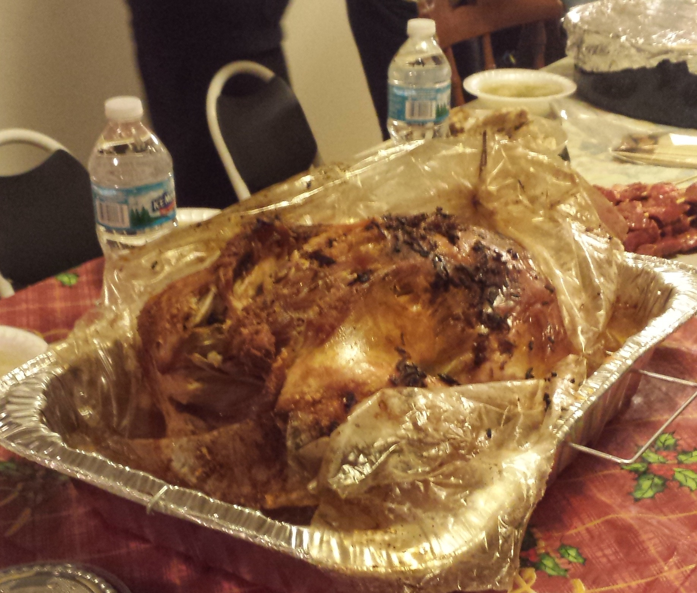

1. **Earned Value Management:**

|  |  |  |  |  |  |  |  |
| --- | --- | --- | --- | --- | --- | --- | --- |
| **Milestone** | **Planned Value** | | **Actual Cost** | | **Earned Value** | | |
| **Planned Duration (hours)** | **Budget ($)** | **Actual Duration (hours)** | **Cost ($)** | **% Complete** | **Earned Value ($)** | **Status** |
| **M#1: check plan** | 8 | 80 | 7 | 70 | 100% | 80 | Early |
| **M#2: check guest** | 2 | 20 | 1 | 10 | 100% | 20 | Early |
| **M#3: check shop stuff** | 4 | 160 | 2 | 128 | 100% | 160 | Early |
| **M#4: check cook and preparation** | 57 | 570 | 43.5 | 435 | 100% | 570 | Early |
| **M#5: check dinner finish** | 5 | 50 | 3 | 30 | 100% | 50 | Early |
| **M#6: check cleanup** | 2 | 20 | 1 | 10 | 100% | 20 | Early |
| **Total** | **78** | **900** | **57.5** | **683** | **100%** | **900** | **Early** |

Note: **Budget** = shopping cost ($120) + labor cost ($10 * 78) = $900

**Actual cost** = actual shopping cost ($108) + actual labor cost ($10 * 57.5) = $683

PV data:

|  |  |  |
| --- | --- | --- |
|  | **Accumulated Planned Value ($)** | **Accumulated Planned Time (Hours)** |
| **M#1** | 80 | 8 |
| **M#2** | 100 | 10 |
| **M#3** | 260 | 14 |
| **M#4** | 830 | 71 |
| **M#5** | 880 | 76 |
| **M#6** | 900 | 78 |

AC data:

|  |  |  |
| --- | --- | --- |
|  | **Accumulated Actual Cost ($)** | **Accumulated Actual Time (Hours)** |
| **M#1** | 70 | 7 |
| **M#2** | 80 | 8 |
| **M#3** | 208 | 10 |
| **M#4** | 643 | 53.5 |
| **M#5** | 673 | 56.5 |
| **M#6** | 683 | 57.5 |

EV data:

|  |  |  |
| --- | --- | --- |
|  | **Accumulated Earned Value ($)** | **Accumulated Earned Time (Hours)** |
| **M#1** | 80 | 7 |
| **M#2** | 100 | 8 |
| **M#3** | 260 | 10 |
| **M#4** | 830 | 53.5 |
| **M#5** | 880 | 56.5 |
| **M#6** | 900 | 57.5 |

The graph above has all the plots for PV, AC and EV lines; with corresponding time and cost each milestone was achieved.

**SV, CV, SPI and CPI at M#1:**

SV = EV – PV = 80 – 70 = 10

CV = EV – AC = 80 – 70 = 10

SPI = EV/PV = 80 / 70 = 1.14

CPI = EV/AC = 80 / 70 = 1.14

**Conclusion: under budget and below planned time**

**SV, CV, SPI and CPI at M#2:**

SV = EV – PV = 100 – 80 = 20

CV = EV – AC = 100 – 80 = 20

SPI = EV/PV = 100 / 80 = 1.25

CPI = EV/AC = 100 / 80 = 1.25

**Conclusion: under budget and below planned time**

**SV, CV, SPI and CPI at M#3:**

SV = EV – PV = 260 – 186 = 126

CV = EV – AC = 260 – 208 = 52

SPI = EV/PV = 260 / 186 = 1.40

CPI = EV/AC = 260 / 208 = 1.25

**Conclusion: under budget and below planned time**

**SV, CV, SPI and CPI at M#4:**

SV = EV – PV = 830 – 625 = 205

CV = EV – AC = 830 – 643 = 187

SPI = EV/PV = 830 / 625 = 1.328

CPI = EV/AC = 830 / 643 = 1.29

**Conclusion: under budget and below planned time**

**SV, CV, SPI and CPI at M#5:**

SV = EV – PV = 880 – 654 = 226

CV = EV – AC = 880 – 673 = 207

SPI = EV/PV = 880 / 654 = 1.35

CPI = EV/AC = 880 / 673 = 1.31

**Conclusion: under budget and below planned time**

**SV, CV, SPI and CPI at M#6:**

SV = EV – PV = 900 – 663 = 237

CV = EV – AC = 900 – 683 = 217

SPI = EV/PV = 900 / 663 = 1.36

CPI = EV/AC = 900 / 683 = 1.32

1. **Post – project assessment:**

I will use the scope triangle to assess this project. The relationship between the time, cost, scope and effort will be assessed individually as follows:

1. Time

The planned time was 78 hours. The actual time was 57.5 hours.

|  |  |  |  |
| --- | --- | --- | --- |
| **Milestone** | **Planned Duration (hours)** | **Actual Duration (hours)** | **Variance (hours)** |
| **M#1: check plan** | 8 | 7 | 1 |
| **M#2: check guest** | 2 | 1 | 1 |
| **M#3: check shop stuff** | 4 | 2 | 2 |
| **M#4: check cook and preparation** | 57 | 43.5 | 13.5 |
| **M#5: check dinner finish** | 5 | 3 | 2 |
| **M#6: check cleanup** | 2 | 1 | 1 |
| **Total** | **78** | **57.5** | **20.5** |

* Discrepancy

It happened in M#4: *check cook and preparation*. The variance is 13.5 hours.

* Reason

We skip the process to brine the turkey. At the same time, we changed the second main course, using fish to replace lamb. Because of this change, we skip the process to brine the lamb, too.

* Improvement

Actually, I overvalued the time. For each milestone, the planned time was always greater than the actual time, especially in M#4. Additional, I should know the time of M#5: *check dinner finish* would not be correct because a lot of stores opened at 6:00 pm and offered second round big sale at 8:00 pm in the Thanksgiving’s night. Maybe a formal dinner will last 5 hours but it is not for a Thanksgiving dinner.

I should do more research before I make a plan. One lesson learned from this project is to never assign time or duration to a project based on your personality, instead all other factors have to be fully accounted for first.

1. Cost

* Discrepancy

The budget for shopping cost is $120 and the actual shopping cost is $108. The variance is $12.

* Reason

We cancelled the contingency plan. I bought a smaller turkey and used fish to replace lamb as the second main course. This change reduced the cost.

* Improvement

The positive side of the project is under budget even I faced some changes. Since the difference between the budget and the actual cost is small, the impact is therefore low. In the future, I should keep this and think about the budget first even I need to change my plan.

1. Scope

The project meets all the scope objectives. Because the work breakdown structure was very specific, we just followed up the schedule to do everything. That is our first time that we have not missed any process to host a party. In the future, I should break down the project into many pieces as much as possible. More process you get, more opportunities to revise or catch up your project.

1. Effort

The product and process quality were all great. The meal was all eaten completely and my guest loved the turkey. It was very delicious. The quality was great. No improvements needed.

1. Success

The Thanksgiving dinner party was a success because it exceeds on the following:

• Quality- The quality was superb and it exceeds the objectives and the expectations

• Cost- The whole project was completed within the budget

• Time- it was below the planned time and the meal itself was delivered at 5:00 pm before our guests entered into our house

• Meal- The meal itself was completely eaten exceeded the expectation.

• Project- The project was a success because it was completed within the budgeted amount of money; the meal was delivered on, underspent, delicious and completely eaten.